The followings will be my report about my model’s performance on different hyperparameters:
Activation: ReLU - Swish - Sigmoid
Same (hyper)parameters with the global seed set to 42:
- Loss: CrossEntropyLoss
- DropOut: p = 0.4
- Optimizer: AdamW with learning rate 0.001 with weight decay 0.00001
- Epochs: 70
Sigmoid: Orange  ReLU: Blue  Swish: Red | Graph
Train accuracy | 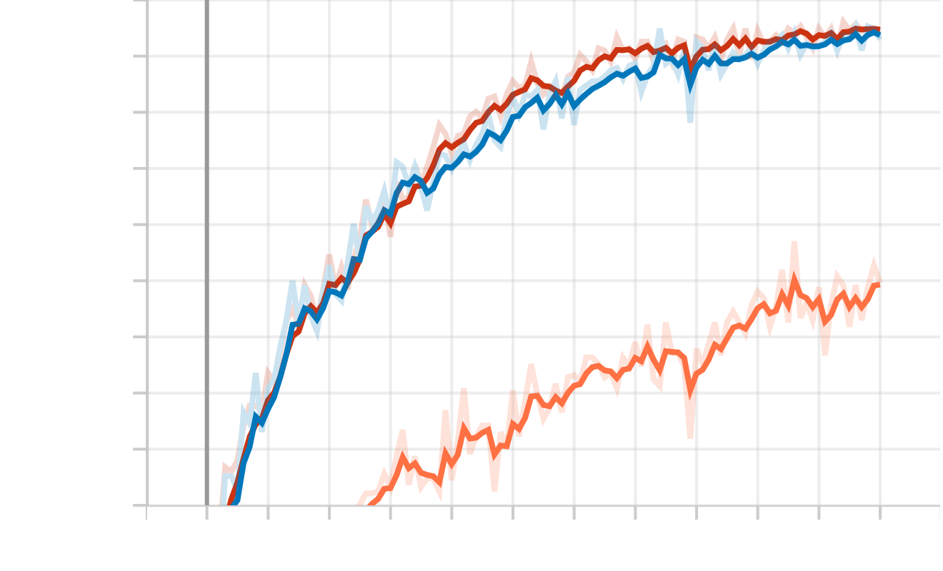
Validation accuracy | 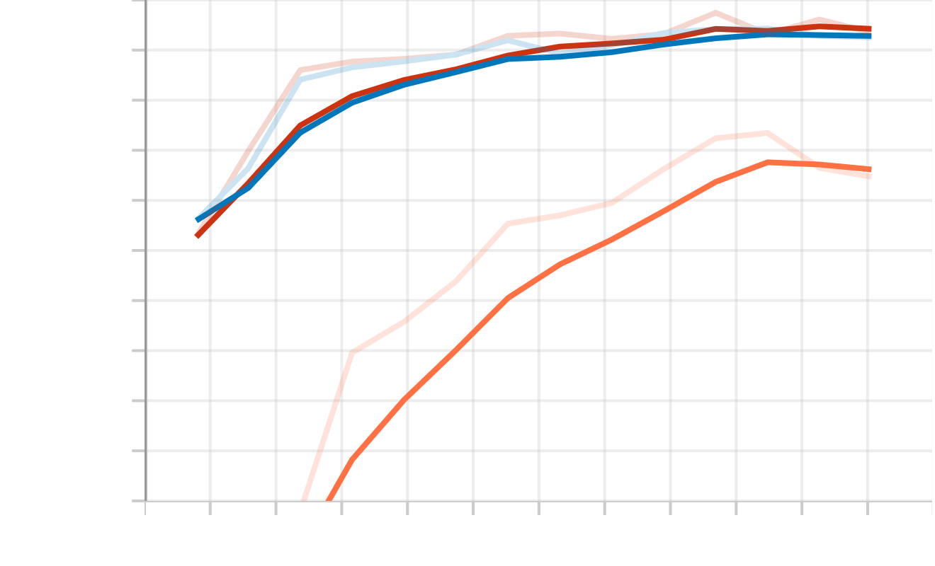
Test accuracy | 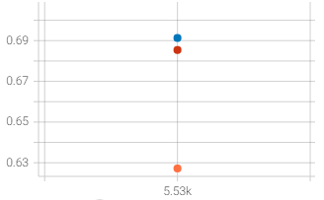

In all phases, Sigmoid underperforms while it is neck-to-neck between ReLU(96% train_acc and 69% test_acc) and Swish (96% train_acc and 68.8% test_acc)
The graph shows that the model is probably under the effect of overfitting, but it is not the focus of this report.

Optimizer: Adam – SGD - AdamW
Same (hyper)parameters with the global seed set to 42:
- Loss: CrossEntropyLoss
- DropOut: p = 0.4
- Activation: Swish
- Epochs: 70
Adam: Orange  SGD: Blue  AdamW: Red | Graph
Train accuracy | 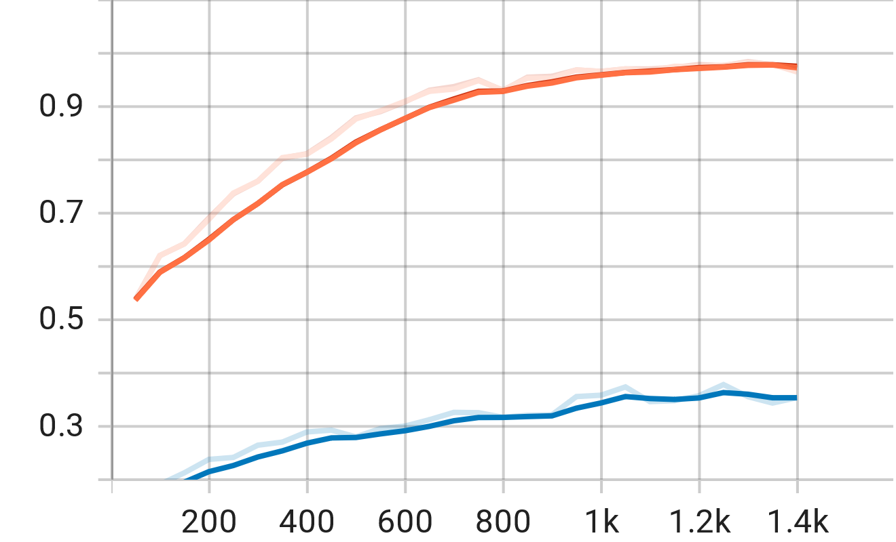
Validation accuracy | 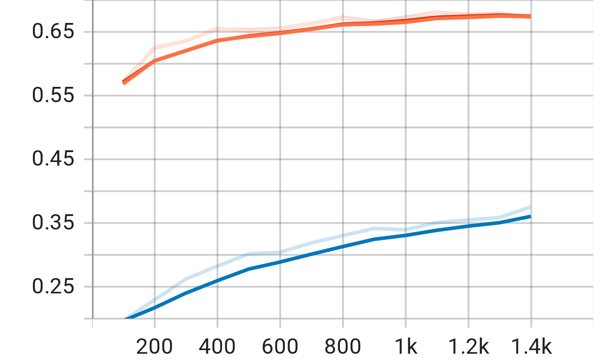
Test accuracy | 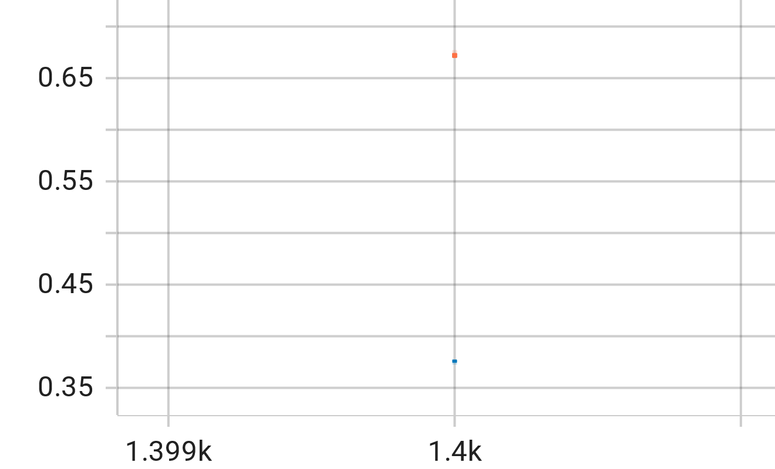

SGD underperforms in all phases while Adam and AdamW result in identical outcomes (they overlap) and achieve (98%, 67%, and 76% on training/validation/test accuracy).
The graph shows that the model is probably under the effect of overfitting, but it is not the focus of this report.

DropOut: p = 0.2 - 0.3 - 0.4
Same (hyper)parameters with the global seed set to 42:
- Loss: CrossEntropyLoss
- Activation function: Swish
- Optimizer: AdamW with learning rate 0.001 and weight decay 0.00001
- Epochs: 70
0.2: Blue  0.3: Red  0.4: Orange | Graph
Train accuracy | 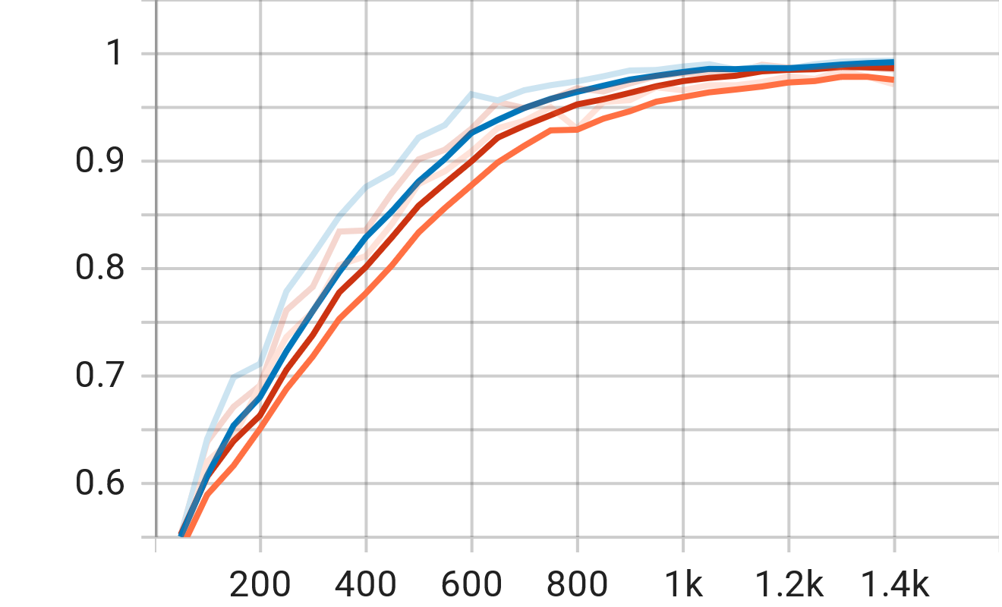
Validation accuracy | 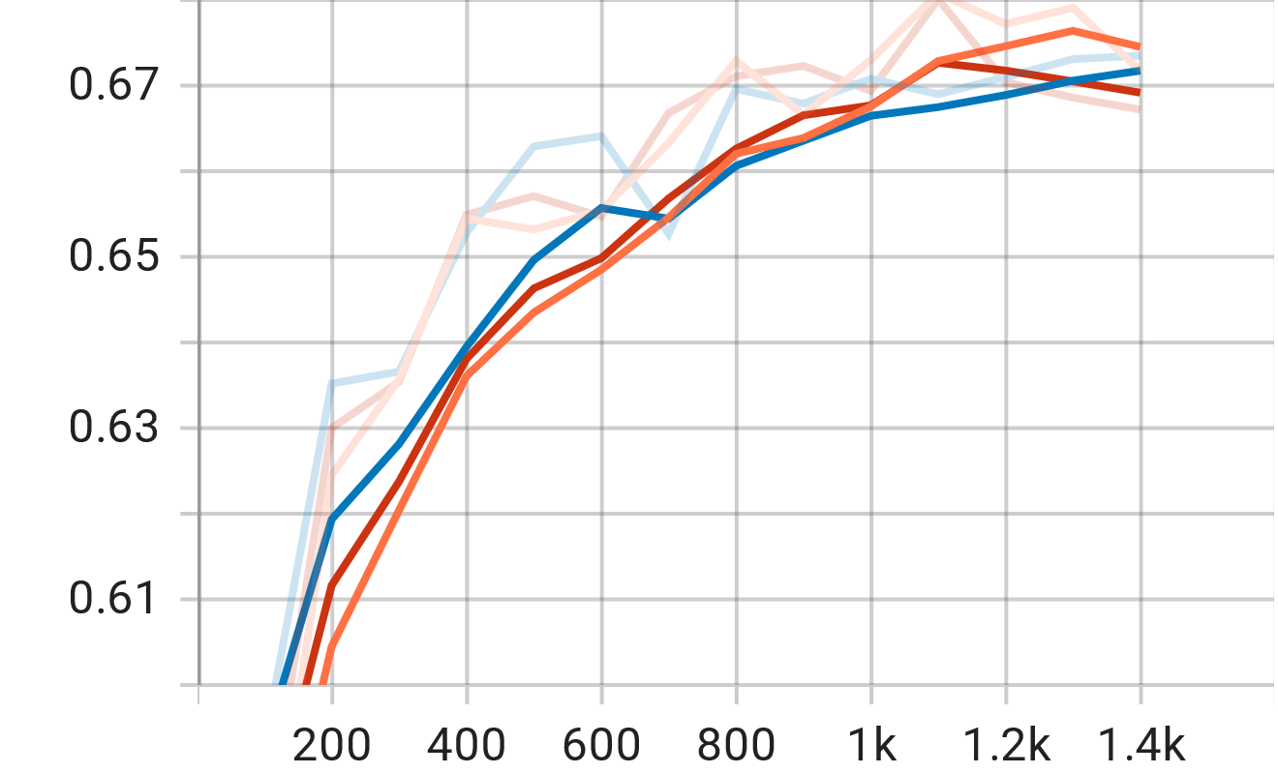
Test accuracy | 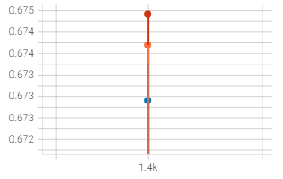
There is no significant difference among the three dropout ratios when the test accuracy in descending order is 0.3, 0.4, and 0.2
The graph shows that the model is probably under the effect of overfitting, but it is not the focus of this report.

